**Homework 1 Solutions**

Question 1:

1. 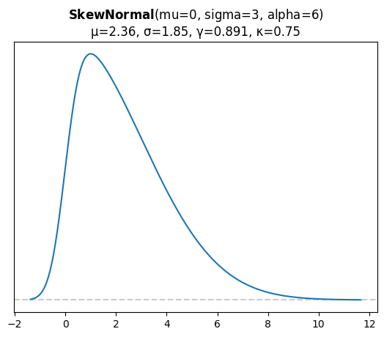d

Sample size 10: mean = 1.91, sigma = 1.64

Sample size 100: mean = 2.58, sigma = 1.79

Sample size 1000: mean = 2.44, sigma = 1.97

As the sample size increases, the values of the parameters are generally closer to the correct values.

1. Similar and answers are in the notebook.

Question 2:

Coin 1 – fair

Coin 2 – loaded

**Probabilities of choosing each coin:**

$$P\left(coin1\right)=P\left(coin2\right)=0.5$$

**Probabilities of flips within each coin:**

$$P\left(heads | coin1\right)=P\left(tails | coin1\right)=0.5$$

$$P\left(heads | coin2\right)=1$$

$$P\left(tails | coin2\right)=0$$

**Bayes:**

$$P\left(coin2 | heads\right)=\frac{P\left(heads | coin2\right)P\left(coin2\right)}{\sum_{i=1}^{2}{P\left(heads | coin_{i}\right)P\left(coin_{i}\right)}}=\frac{1⋅0.5}{0.5⋅0.5+ 1⋅0.5}=\frac{2}{3}$$

Question 3:

1. The likelihood is the normal distribution with parameters $μ, σ$.

$μ$ has a normal prior with (N(0,2)) and $σ$ has a half normal prior.

1. The posterior will have two parameters – one for each $μ$ and $σ.$

$P\left(μ, σ | Y\right)=\frac{P\left(Y | μ, σ\right)P\left(μ\right)P\left(σ\right)}{P(Y)}$

$$P\left(Y | μ, σ\right)=\frac{1}{\sqrt{2π}σ}e^{-\frac{{\left(Y-μ\right)}^{2}}{2σ^{2}}}$$

$$P(μ)=\frac{1}{\sqrt{8π}}e^{-\frac{μ^{2}}{8}}$$

$$P(σ)=\frac{1}{\sqrt{2π}⋅0.75}e^{-\frac{σ^{2}}{2{⋅0.75}^{2}}}$$

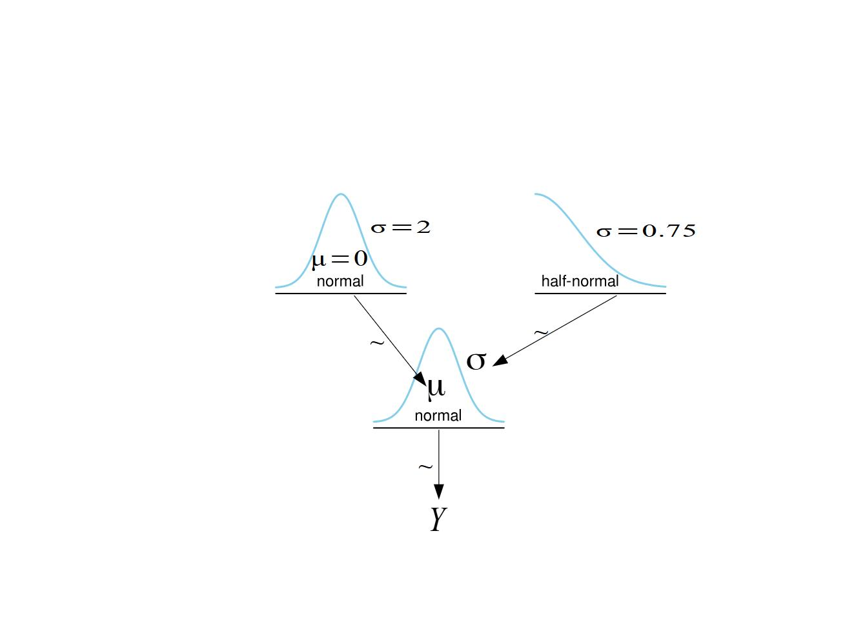

Question 4:

1. 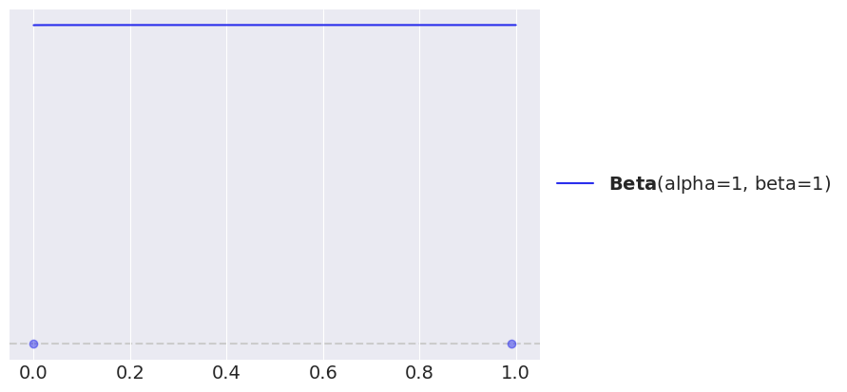

2. 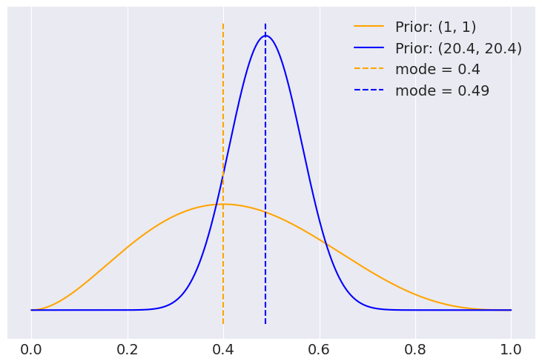
3. 